Ohad Shpindel

P2MP Plotter

Quick Guide   
  
(for ver 1.1)

GUI operation phases:

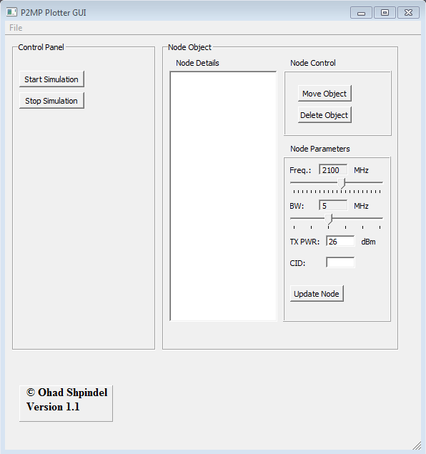

* Password for the application: jrc123

1. Under "Node Parameters" pane select initial Frequency, Bandwidth and Tx Power for the nodes.
2. Create a new plot by selecting File > New Plot  
   (on this version only Random Nodes is available)
3. On the new "plot window" choose the number of wanted nodes and press Apply

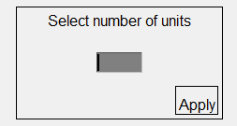

1. Plot window:

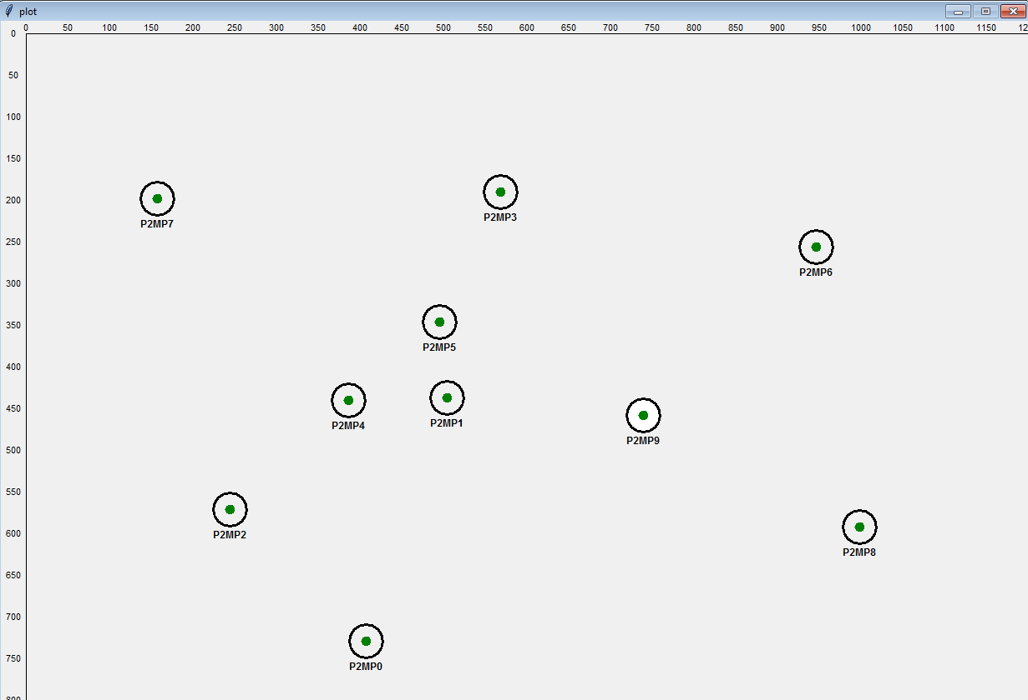

1. After the Plot window is created use the mouse to select a node by pressing its inner circle.  
     
   The Node will become blue and its details will appear on the "Node Details" pane  
     
   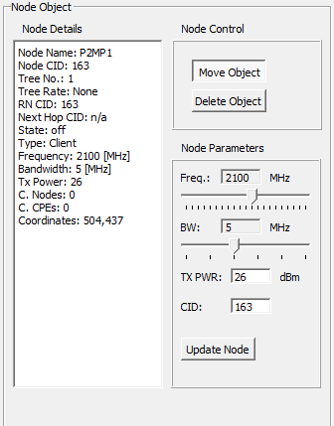  
     
   now you can select "Move Object" from the "Node Control" pane to move the node to other location on the plot, select "Move Object" and press the new location on the plot.  
   (The "Delete Object" option is currently not available)  
     
   The node parameters can be changed individually from the "Node Parameters" pane, choose new parameters for the selected node and press "Update Node"
2. When done configuring the nodes select "Start Simulation" from the "Control Panel" pane.  
   After starting the simulation node parameters and location can't be changed.  
     
   The simulation will start to connect the Nodes to one tree and will choose a "Root Node" For it.  
     
   *Note: Each node is acting individually and simultaneously to the others.*  
   Now you can select nodes again and observe its new details.
3. Before starting a new plot select "Stop Simulation" from the "Control Panel" pane; close the old plot and repeat the procedure.

Road Map

Next versions will include:

1. Better network connection algorithm.
2. More pass loss Functions for better accuracy
3. Plot scaling control for different zoom.
4. Simulation improvements:   
   more indications, time control, real time with moving Nodes   
   and more.
5. Statistics collection.